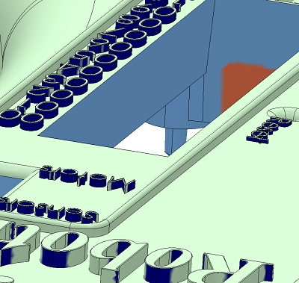

9. The part has thin features that need to be increased in thickness to the minimum thickness as indicated by the color code below:  
  
    minimum thickness = 0.020 in  
    minimum thickness = 0.026 in  
  
An updated file is needed to make this part.

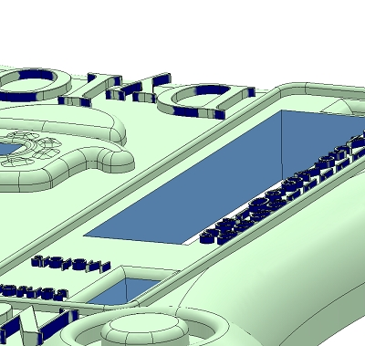

10. The part has thin features that need to be increased in thickness to the minimum thickness as indicated by the color code below:  
  
    minimum thickness = 0.020 in  
    minimum thickness = 0.026 in  
  
An updated file is needed to make this part.

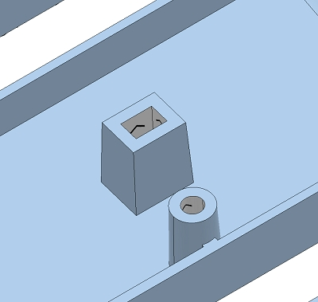

12. 0.5° minimum draft is required on faces with arrows.  
  
Arrows indicate the pull direction for faces in the mold. Draft and wall thickness should be added to these faces to enable machining of the mold and to facilitate ejection of the part from the mold. If these changes are not made we may not be able to make a mold for your parts or to eject the parts from the mold. If the indicated draft and wall thickness cannot be added to your model, please apply as much as you can and call us. For details, clarification, options, or alternatives, please contact a Customer Service Engineer at customerservice@protolabs.com or 877.479.3680.  
  
An updated file is needed to make this part.